**ORGANIC CHEMISTRY**

**PINACOL PINACOLONE REARRANGEMENT**

Submitted By: A.KUPPUCHAMY (19CHP032)

### **Introduction:**

Pinacol Pinacolone rearrangement is a very important process in organic chemistry for the conversion of 1,2 diols into carbonyl compounds containing a carbon oxygen double bond. This is done via a 1,2-migration which takes place under acyl conditions. The name of the rearrangement reaction comes from the rearrangement of [pinacol](https://en.wikipedia.org/wiki/Pinacol) to [pinacolone](https://en.wikipedia.org/wiki/Pinacolone). This reaction was first described by [Wilhelm Rudolph Fittig](https://en.wikipedia.org/wiki/Wilhelm_Rudolph_Fittig) in 1860 of the famed Fitting reaction-involving coupling of 2 aryl halides in presence of sodium metal in dry ethereal solution. The pinacol pinacolone rearrangement process takes place via a 1,2-rearrangement as discussed earlier. This rearrangement involves the shift of two adjacent atoms. This reaction is a result of the work of the German chemist William Rudolph Fittig who first described it in the year 1860.

### **History:**

Although Fittig first published about the pinacol rearrangement, it was not Fittig but [Aleksandr Butlerov](https://en.wikipedia.org/wiki/Aleksandr_Butlerov) who correctly identified the reaction products involved.

In an 1859 publication [Wilhelm Rudolph Fittig](https://en.wikipedia.org/wiki/Wilhelm_Rudolph_Fittig) described the reaction of [acetone](https://en.wikipedia.org/wiki/Acetone) with [potassium](https://en.wikipedia.org/wiki/Potassium) metal. Fittig wrongly assumed a [molecular formula](https://en.wikipedia.org/wiki/Molecular_formula) of (C3H3O)n for acetone, the result of a long-standing atomic weight debate finally settled at the [Karlsruhe Congress](https://en.wikipedia.org/wiki/Karlsruhe_Congress) in 1860. He also wrongly believed acetone to be an alcohol which he hoped to prove by forming a metal alkoxide salt. The reaction product he obtained instead he called paraceton which he believed to be an acetone [dimer](https://en.wikipedia.org/wiki/Dimer_(chemistry)). In his second publication in 1860 he reacted paraceton with [sulfuric acid](https://en.wikipedia.org/wiki/Sulfuric_acid) (the actual pinacol rearrangement).

[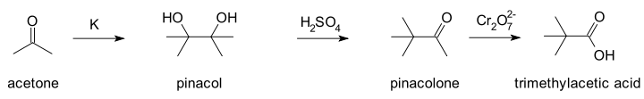](https://en.wikipedia.org/wiki/File:Acetone2pinacolone.svg)

Again Fittig was unable to assign a molecular structure to the reaction product which he assumed to be another isomer or a polymer. Contemporary chemists who had already adapted to the new atomic weight reality did not fare better. One of them, [Charles Friedel](https://en.wikipedia.org/wiki/Charles_Friedel), believed the reaction product to be the [epoxide](https://en.wikipedia.org/wiki/Epoxide) tetramethylethylene oxide in analogy with reactions of [ethylene glycol](https://en.wikipedia.org/wiki/Ethylene_glycol). Finally Butlerov in 1873 came up with the correct structures after he independently synthesised the compound [trimethylacetic acid (Pivalic)](https://en.wikipedia.org/wiki/Pivalic_acid) which Friedel had obtained earlier by oxidizing with a [dichromate](https://en.wikipedia.org/wiki/Dichromate).

Some of the problems during the determination of the structure are because carbon skeletal rearrangements were unknown at that time and therefore the new concept had to be found. Butlerov theory allowed the structure of carbon atoms in the molecule to rearrange and with this concept a structure for pinacolone could be found.

### **Pinacol and Pinacolone:**

Pinacol is a compound which has two hydroxyl groups, each attached to a vicinal [carbon](https://byjus.com/chemistry/carbon/) atom. It is a solid organic compound which is white in colour.

The IUPAC name of Pinacolone is 3,3-dimethyl-2-butanone. Pinacolone is a very important ketone. It has a peppermint like or camphor like odour and appears to be a colorless liquid.

### **Pinacol Pinacolone Reaction:**

The pinacol pinacolone rearrangement proceeds through the formation of an intermediate which is positively charged. The methyl group in this intermediate proceeds to migrate from one carbon to another. This reaction can be given by:  
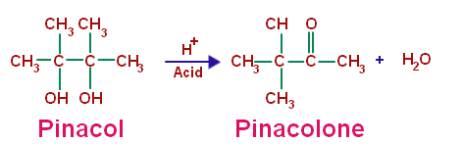

## Pinacol Pinacolone Rearrangement Mechanism:

The Pinacol Pinacolone rearrangement mechanism proceeds via four steps. Each of these steps are explained below.

**Step 1:**Since the reaction is carried out in an acidic medium, the hydroxide group of the pinacol is protonated by the acid.

**Step 2:**Water is now removed from the compound, leaving behind a carbocation. This carbocation is tertiary and therefore stable.

**Step 3:**The methyl group shifts to the positively charged carbon in a rearrangement of the compound.

**Step 4:**The oxygen atom which is doubly bonded to the carbon is now deprotonated, giving rise to the required pinacolone.

This reaction mechanism can be illustrated as:

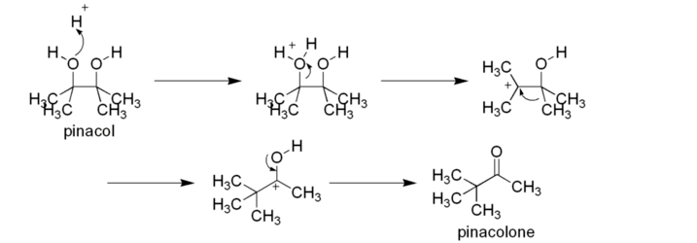

Thus, the required Pinacolone product is generated. It is important to note that this rearrangement is regioselective in nature. The rearrangement of the more stable carbocation yields the major product.

## Uses of Pinacolone:

The uses of the pinacolone product produced from the pinacol pinacolone rearrangement include:

* Pinacolone is used in [Pesticides](https://byjus.com/chemistry/pesticides/), Fungicides, and Herbicides.
* Pinacolone is used to prepare the cyanoguanidine drug – pinacidil.
* Another drug use of Pinacolone is its use in Stiripentol, which is used to treat epilepsy.
* Pinacolone is used to produce triadimefon which is used to control fungal diseases in agriculture.